Adult Services Report February:
Trainings:
February was a busy month for training. Brittany Leath and I went to Garrett for an Adult Programming meeting where we got some great ideas including a boat safety class for the summer through the DNR. KPL hosted a Continuous Improvement meeting on February where local libraries brainstormed ideas for summer reading. Managers are starting training through the Disney Institute and then each department will train as well.
Staffing:
Matt Tibbs put in his resignation. He did a great job hosting book clubs and bingo but he has a full time job and new opportunities came up. Andrea Freeze was hired as the new adult services assistant. She will work Thursday evenings and one Saturday a month. She has experience as a JAG teacher so she will be great at helping patrons with resumes, interviewing skills, and basic computer help.
Programs:
Our fitness classes continued to boom in February. Patrons seem to enjoy pound and yoga especially.
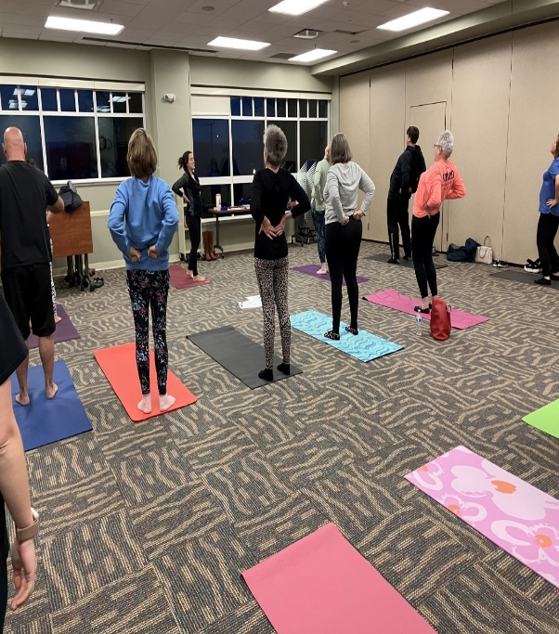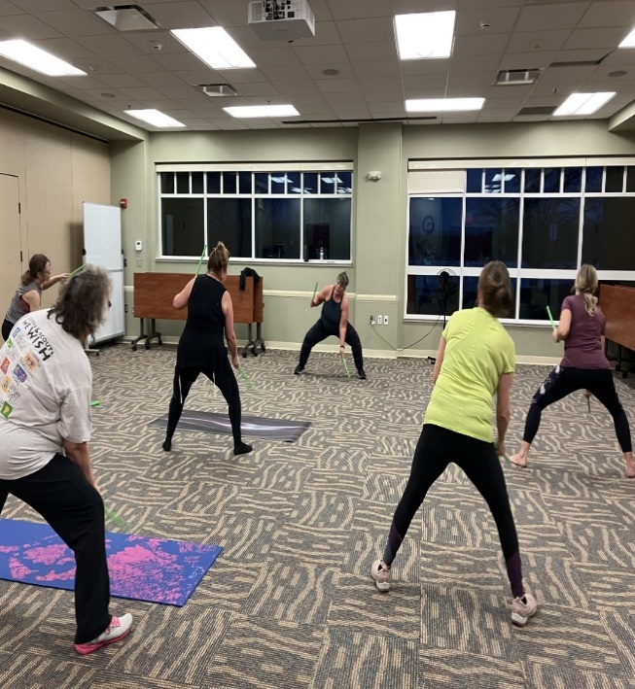

We also were lucky enough to host Lutheran Life Villages for Brunch Club and that turned into a tour and a scheduled visit for them once a month starting in March.
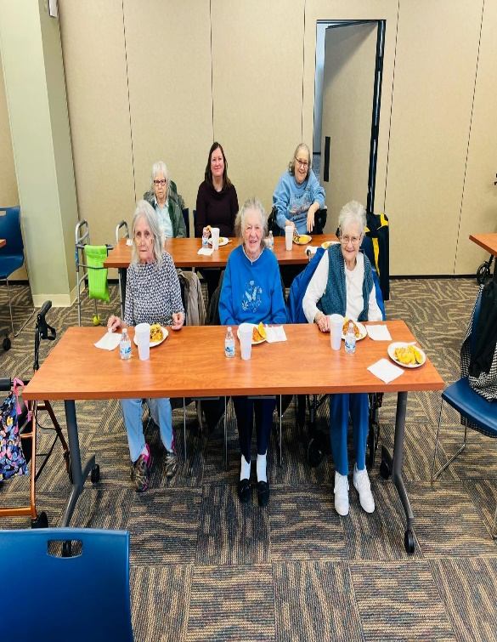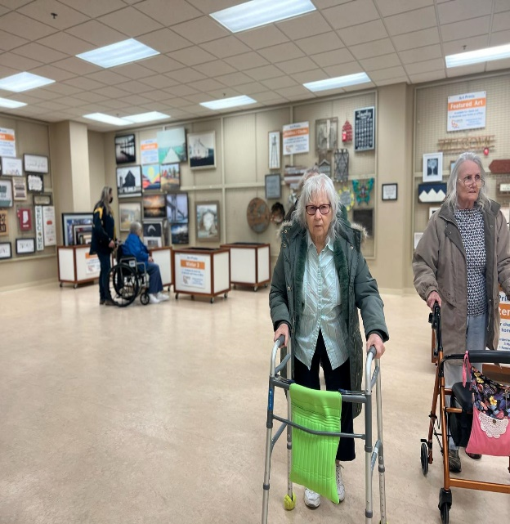
Collections:
We have been working on creative displays to boost circulations. We are also ordering more books for Libby so that our patrons wait times are shorter. KPL has been asked to present at a meeting in Marion in March to discuss our Library of Things so Brittany, Leah, and Mary have been working on that presentation.

